FM200 Cylinder
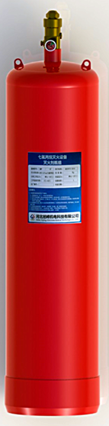

1 Overview
FM200 cylinders are supplied by professional cylinders manufacturing enterprises with Class I, Class II, and Class III Certificate of pressure vessels and B2 (1) level qualifications. The main products are tower container, heat exchanger, storage tank, pressure sterilizer, Class I, Class II, and Class III of pressure vessel, nitrogen cylinders, suspension (powder) welding cylinder, methyl bromide cylinders, liquid ammonia, chlorine and other various kinds of welding cylinder.
2 Technical Parameter
Model | Nominal volume (L) | Nominal diameter  （mm） | Height（mm） | Weight  （Kg） | Nominal pressure | Hydrostatic test | Agent Type | Material
FMP-40 | 40 | Ø300 | ~736±10 | 41 | 4.2MPa | 6.3MPa | HFC-227ea | HP345/Q345R
FMP-70 | 70 | Ø350 | ~895±10 | 58
FMP-90 | 90 | Ø350 | ~1095±10 | 69
FMP-120 | 120 | Ø350 | ~1415±10 | 85
FMP-150 | 150 | Ø400 | ~1467±10 | 105
FMP-180 | 180 | Ø400 | ~1607±10 | 122

