Single / Double bottle cabinet

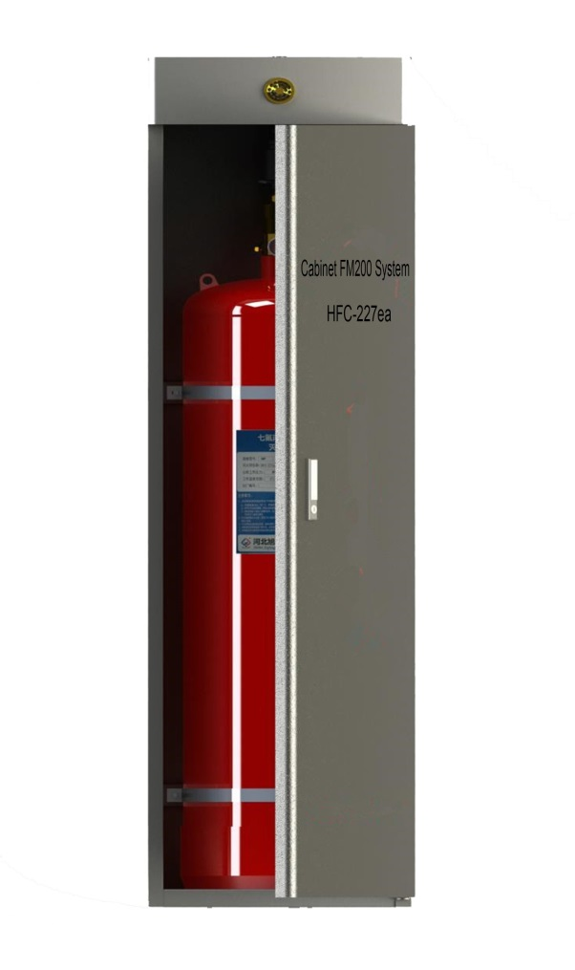

Technical Parameter

Model | Specification | LXWXH | Product description
Single - bottle cabinet | 40/70L | 500X500X1450 | The cabinet is divided into two types : assembly and welding; the thickness of the assembly plate is 1.2mm; welding plate thickness is 1.0mm; the box shape, size can be customized
 | 90L | 500X500X1600
 | 120L | 500X500X1900
 | 150L | 550X520X1900
 | 180L | 550X520X2100
Double - bottle cabinet | 40/70L | 500X900X1450
 | 90L | 500X900X1600
 | 120L | 500X900X1900
 | 150L | 550X1000X1900
 | 180L | 550X1050X2100

